Assignment 2
Distributed systems
Sprencz Róbert

In this assignment, our task was to extend our existing microservices with a monitor microservice, which takes fictional measurements from a producer service through rabbit mq. Based on these measurements, we have to notify users through websockets if the consumption exceeded the maximum value.

Conceptual architecture
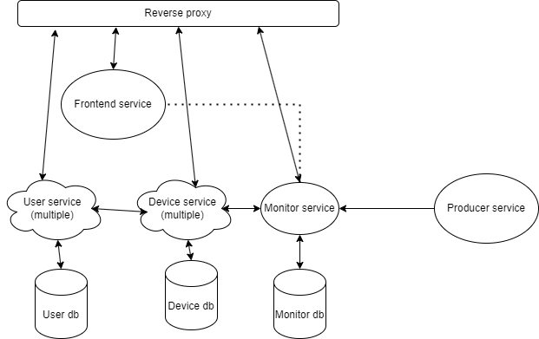
In this diagram we see a simple high level approach to this problem.
We have three databases, each of which is used by microservices. There can be multiple user and device microservices, but we only have one monitor service.
A reverse proxy resides above all microservices, so that when a request arrives, it is redirected to the proper microservice.
The user service
Same as in the previous assignment.
The device service
Same as in the previous assignment, but notifies the monitor service on device changes.
The monitor service
This service contains consumption info related to devices. It has knowledge of how much
The frontend service
It supports energy statistics coming from the monitor service and it can handle a websocket notification that a device has exceeded the maximum consumption
Deployment
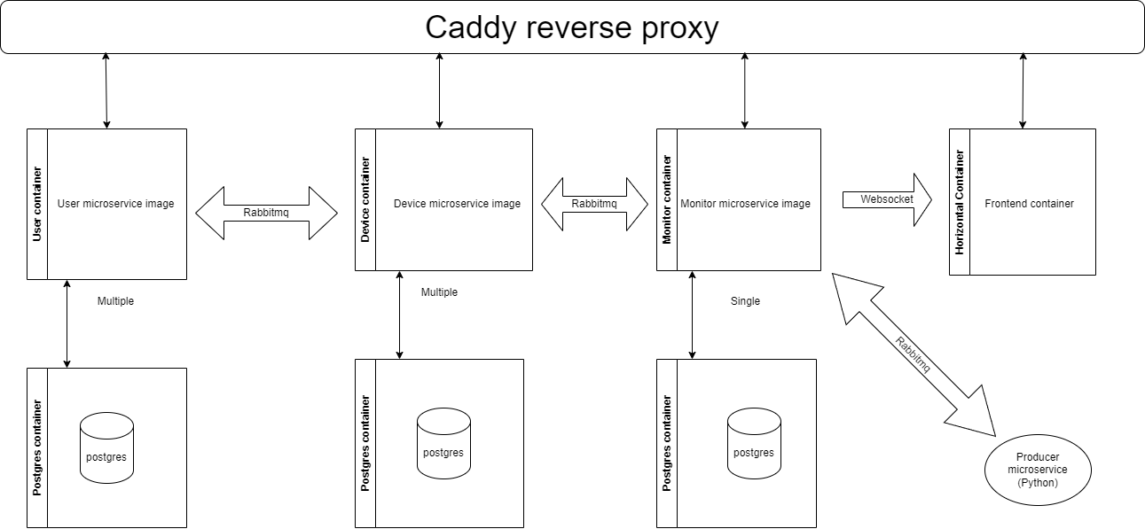
In order to deploy our microservices, I have used Docker containerization. The device and the user containers can be replicated, such that multiple instances can be run.
The producer microservice is a Python app, that generates measurement data.
The monitoring microservice periodically processes this data and stores it. If consumption is deemed high, it notifies the frontend microservice through a websocket.
The frontend now can also display the telemetry on charts.
The databases are Postgres, with containers pulled from the Docker repository.
The frontend service is made with Vue and the backend services are made with NodeJS with Express to implement the REST api.
Communication between microservices is usually done by RabbitMq.
Build and execution considerations
In the docker compose file, the user can decide how many replicas of the user and device microservices it needs. Afterwards, the reverse proxy is supposed to handle the requests.

